Moch. Naufal Ardian Ramadhan  
15  
SIB 1G

<https://github.com/NaufalArdian12>

**Jobsheet 6**

**Selection part 2**

2.1 experiment 1

make a file.java then type the following code

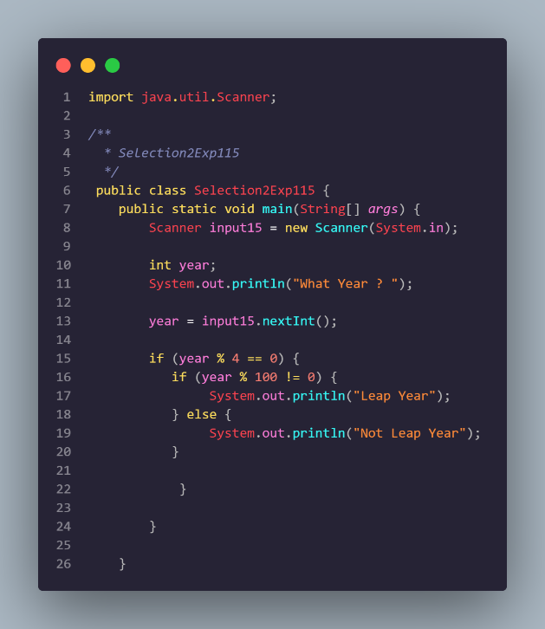

The result is gonnna be like this

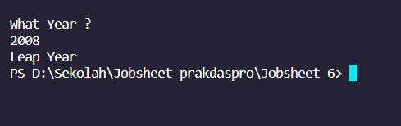

Question

1. What is the output if the input is 2100? Please explain your answer! How to ensure that

output complies with regulations (2100 is not a leap year)?  
**Will not appear output, then give else in nested**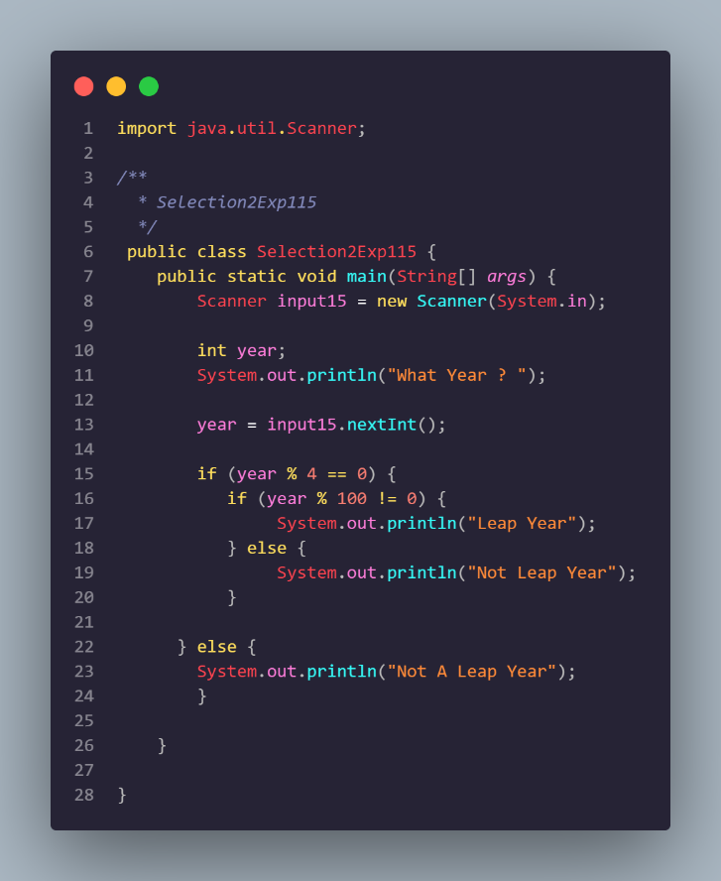

The result is gonnna be like this

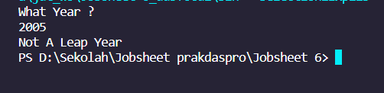

4. The year 2000 is a multiple of 4 and a multiple of 100, but it is a leap year. So that, there

is an additional rule to determine leap year. If the year is a multiple of 100 and is also a

multiple of 400 then that year is a leap year. Modify the program to adjust to these rule!

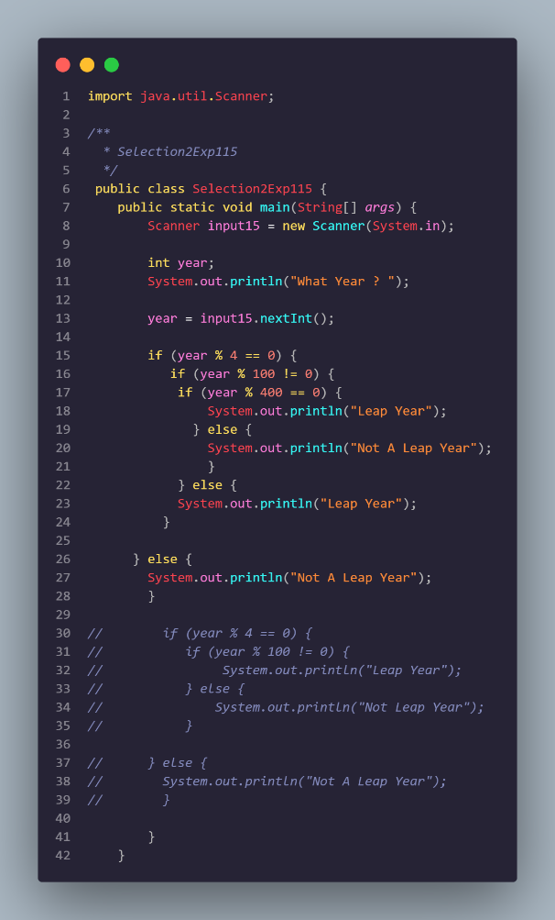

The result is gonnna be like this

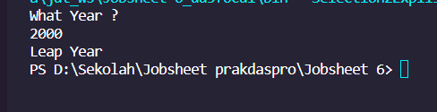

2.2 experiment 2

make a file.java then type the following code

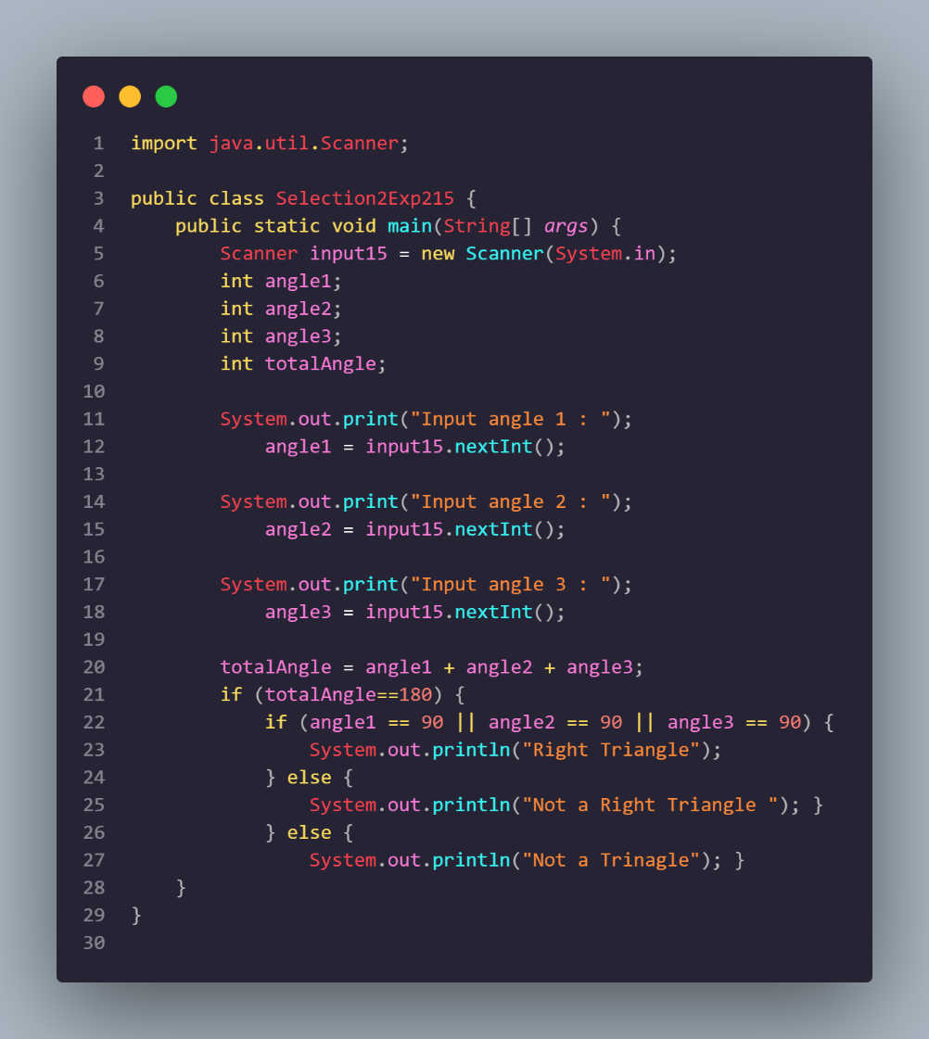

The result is gonnna be like this

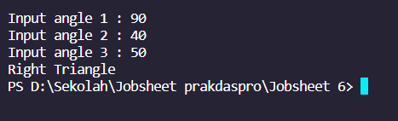

Question

1. Modify the source code, so that it can detect the other types of triangles (equilateral triangle and isosceles triangle)

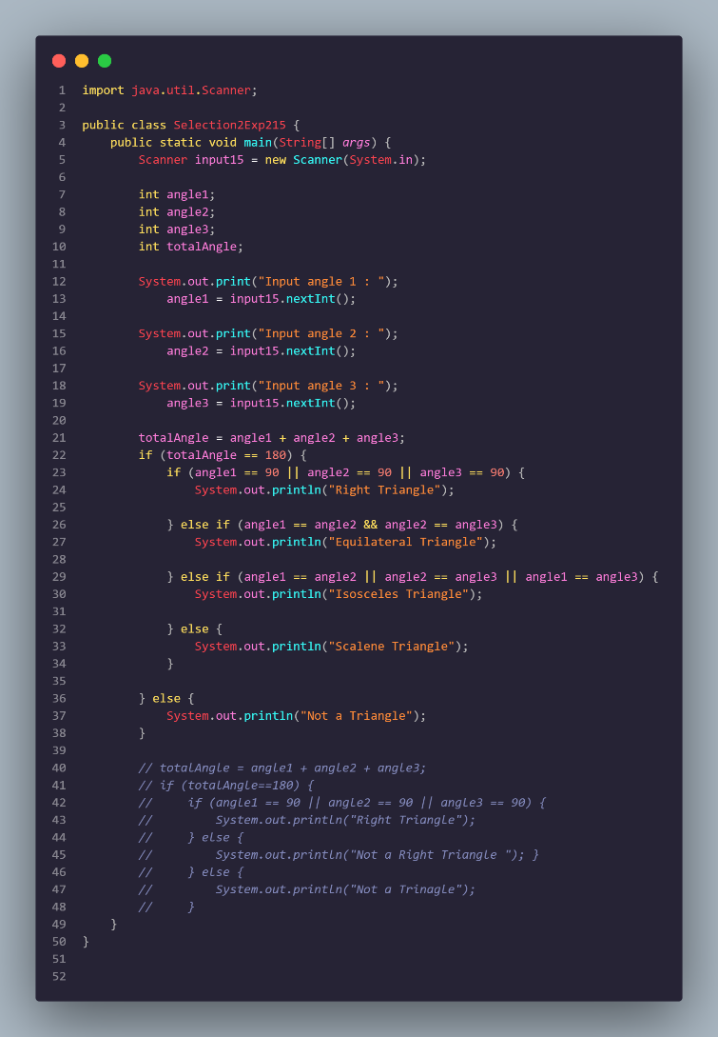

The result is gonnna be like this

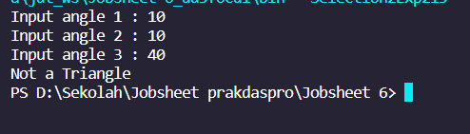

2.3 experiment 3

make a file.java then type the following code

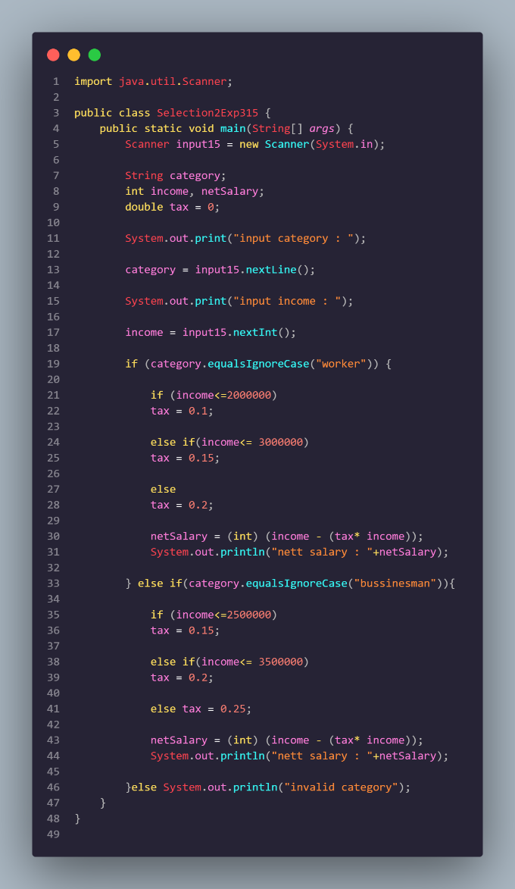

The result is gonnna be like this

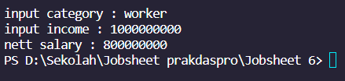

Question

1. Explain the function of (int) in the syntax netSalary= (int) (income - (income * tax));

The (int) in the syntax netSalary= (int) (income - (income * tax)) is a type casting operator that converts the result of the expression (income - (income * tax)) from a double to an integer. This is done because the net salary is expected to be an integer value, and the calculation of income - (income * tax) may result in a double value.

2. Run the program by entering category = BUSINESSMAN and income = 2000000. Observe what happens! What is the use of equalsIgnoreCase?

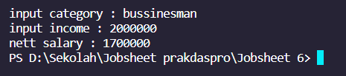

When the program is run by entering category = “businessman” and income = 2000000, the output is "nett salary : 1500000". The use of equalsIgnoreCase is to compare the category entered by the user with the strings "worker" and "businessman" without considering the case of the letters. This means that if the user enters "BUSINESSMAN" instead of "businessman", the program will still recognize it as a valid category.

3. Change equalsIgnoreCase to equals, then run the program by entering category = BUSINESSMAN and income = 2000000. Observe what happens! Why is the result like that? What is the use of equals?

When equalsIgnoreCase is changed to equals, the program will not recognize "BUSINESSMAN" as a valid category because it is not equal to "businessman". Therefore, the output will be "invalid category". The use of equals is to compare the category entered by the user with the strings "worker" and "businessman" while considering the case of the letters. This means that if the user enters "BUSINESSMAN" instead of "businessman", the program will not recognize it as a valid category.

